National Curriculum subject content

Year 8 History: gain historical perspective by placing knowledge into different contexts; understand connections between local, regional and national history and between cultural, economic, military, political and social history.
A Tale of Two Sieges Ponteland High School

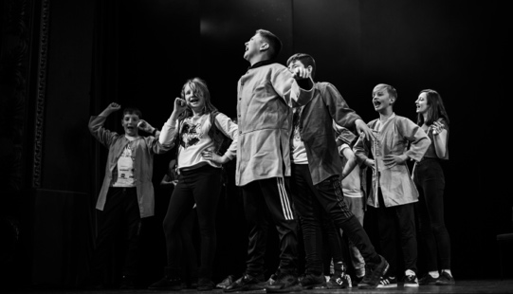
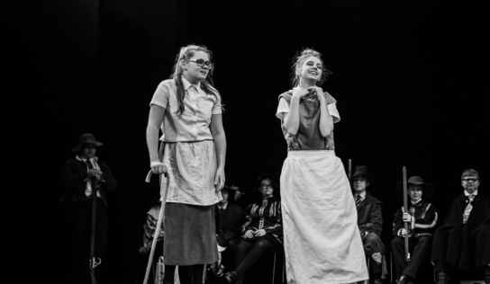
Skill development

- Developing historical knowledge
- Using authentic resources
- Working independently and in a group
- Working towards a goal by listening to instructions and following direction
- Creating a final product (drama production)
- Communicating ideas to an external audience (during the final presentation to the partner school)
Project Summary

This project involved two schools, Ponteland High School and Newark Academy, who worked on a similar project plan but in their respective schools. Organised by Newcastle University Education Outreach, the Ponteland High School Year 8 students worked with Newark National Civil War Centre, Cap-a-Pie Theatre company, Time Bandits and Lydia Wysocki​ from Applied Comics Etc. Ponteland students visited Robinson Library for a series of workshops and lectures on the Civil War, focusing on daily and military life, then spent a week off timetable preparing a play with Time Bandits and Cap-a-Pie Theatre Company based on the Siege of Newcastle. Students then travelled to Newark to visit the Civil War Centre where they had a tour of the museum and performed their play in front of the Newark students in the adjoining theatre.

Cultural capital

The project launch event involved a whole day visit to Newcastle University where Ponteland students took part in a workshop on comics and historical illustrations, had a lecture from a history academic, and examined authentic artefacts in the Special Collections and Archives.
Students incorporated their historical knowledge into the development of a play with facilitators from the theatre company, then travelled to Newark where they explored the National Civil War Centre and performed their play to their partner school.
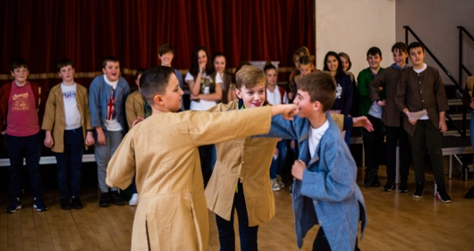
Gatsby Benchmarks

BM4. Linking curriculum learning to careers​ BM 5: Encounters with employers and employees​ BM 6: Experience of workplaces​ BM7: Encounters with further and higher education​

Session 1 | Session 2 | Session 3 | Session 4 | Session 5 | Session 6 | Session 7
Students visit Newcastle University to take part in workshops and lectures.  Supported by University academics, Education Outreach, Applied Comics Etc. | Students take part in a week of writing and producing a play on the topic of the Civil War with facilitators from Cap-a-Pie Theatre Company and Time Bandits.  Sessions all supported by Cap-a-Pie Theatre Company, Time Bandits and teachers from History department at Ponteland High School |  |  |  |  | Showcase: Students present play at Newark Civil War Centre.  External audience: Newark Academy students, invited guests
“It’s one of the proudest moments of my career!” (Head of History Department)

“You learn better as it’s more interesting and you care about it more” (Student)

“Opportunities like this are brilliant – they’ll remember this for years and years!” (Head of History Department)

“I’m not as shy, and I’ve met new people that I’d never seen before even though we’re in the same school!” (Student)

“This helped me with the way I remember things – I can use it for homework and the way I learn, like remembering information.” (Student)

“You get a rewarding outcome as you physically see the progress you’ve done.” (Student)

Project feedback

Launch event/ Final product and showcase

The project launched with a visit to Newcastle University, where students took part in workshops on comics and historical illustrations, received a lecture on the civil war, and examined the authentic artefacts in the Special Collections and Archives.
The aim of the project was to introduce the students to the topic of the civil war using authentic materials and encouraging them to think about daily and military life during the period.
The showcase event saw Ponteland High School students travel to the National Civil War Centre in Newark, where they were given a tour of the centre and practised their play in the adjoining theatre. Finally the two schools involved performed their play to each other.

Project activity and timescale

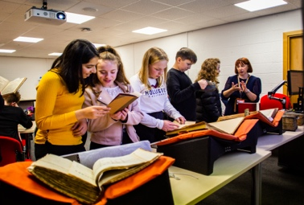
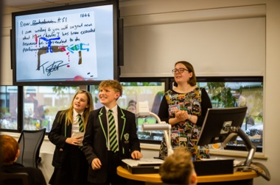
Learning for next time

  - Facilitators:
- Theatre company facilitators commented that the pupils had huge enthusiasm and their subject knowledge prior to the week of play preparation was excellent – this is a key factor in the success of the week, as they could concentrate on skill development and producing a project outcome, rather than introducing the topic knowledge. However, they felt they could have benefitted from some extra research time after the initial workshops with Time Bandits, so pupils could extend their knowledge independently.
- A neutral space would have been preferable, as the facilitators noted some pupils were distracted being in their former primary school.
- “You can’t develop these skills in one week” – facilitator’s comment. Teachers need to think of how these can begin to work on the skills prior to the project and continue to embed them after it has concluded.
  - Teachers:
- Teacher support is vital – the whole history department were involved in working with the pupils throughout the week and the Head of History commented that the Senior Leadership team at the school were in full support of the project and of PBL in general.
  - Education Outreach:
- Touching artefacts brought history to life
- Opportunity of working with creative practitioners and professionals was a unique and enriching experience
- Deeper learning occurred through different style of ‘fun’ learning (evidenced in videos)
- Importance of going outside the classroom – ‘going places, meeting people, doing things’
Useful links/resources/ideas

Newcastle University Robinson Library Special Collections and Archives Education Outreach: https://www.ncl.ac.uk/library/services/education-outreach/
Cap-a-Pie Theatre Company: https://www.cap-a-pie.co.uk/
If your school isn’t near Newcastle, find your local university/college library outreach teams.
Resources relating to this specific project on our website.
General resources on our website: blank planning tools, links to useful websites, more case studies

